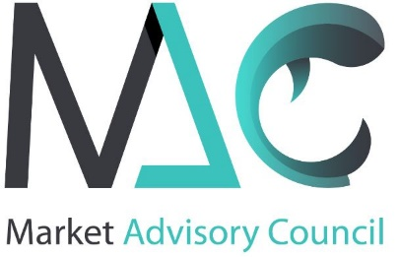

Market Advisory Council - Membership application form

PLEASE COMPLETE THE FORM IN FULL AND RETURN A SCAN BY E-MAIL AND THE ORIGINAL BY POST TO:

The Secretariat of the Market Advisory Council
EBCD
10 Rue de la Science, 1000 Brussels, Belgium
Tel.: +32 489 84 11 49
secretary@marketac.eu

APPLICANT INFORMATION
Organization name in full:
Short name: |  | Legal Status:
Registration Number: |  | Transparency number:
Registered address:
City: | Postcode: |  | State:
CONTACT PERSON
Name:
Position in organization:
Phone: | E-mail:
NATURE/ACTIVITY OF THE ORGANISATION
VALUE SUPPLY CHAIN or OTHER INTEREST GROUP (please specify):
ORGANISATION OBJECTIVES (statutes to be attached):
MEMBERSHIP TYPE (companies, individuals…):
GEOGRAPHICAL COVERAGE (national, regional…):
PLEASE EXPLAIN WHY YOUR ORGANISATION WANTS TO BE A MEMBER OF THE MAC:
INTEREST IN WORKING GROUPS OF THE MAC
My organization would be interested in participating in the Working Groups on:

Working Group 1 EU Production

Working Group 2 EU Markets
Working Group 3 EU control and sanitary issues, consumer rules

PLEASE NOTE ANY CONDITIONS OR RESERVATIONS
ACTIVITY COMMITMENT
Fees for the financial year 2019-2020: €200 to be Member of the General Assembly and €300 to be member of the Working Groups
SIGNATURES & OFFICIAL STAMP
The undersigned, as a legal representative of the applicant organization, hereby declares that the organization, in being accepted as a Member Organization of the MAC, will fulfil all the obligations of membership, as stated in the official statutes and the internal Rules of Procedure that are agreed by the General Assembly of the MAC, and commits to payment of the annual fees within 30 days of the receipt of the request for payment.
Signature of applicant: | Date:
Official stamp of organization:

